**GET METHOD Demonstartion:**

It is used to fetch the data from the url we are giving the below box. By clicking on below send button we get the fetched data of the url server.

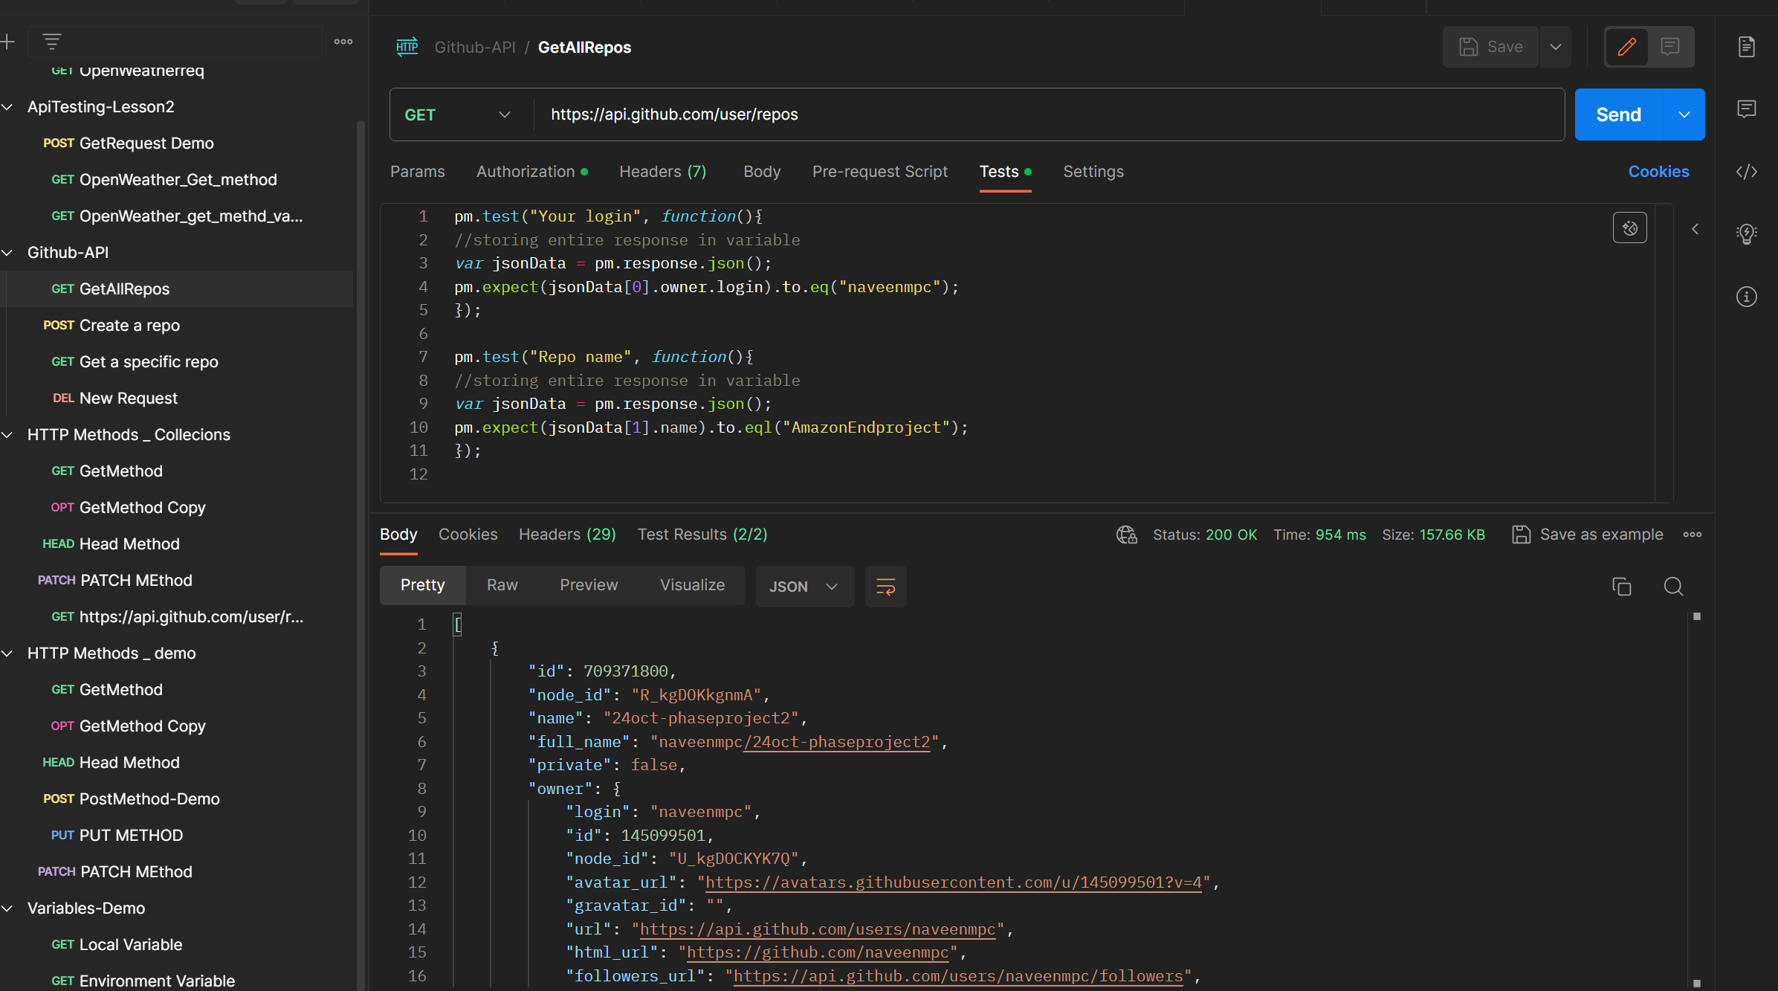

Get Method via a Tests ..Results got executed by having two datas fetching.

